KURTOSIS
The measure of kurtosis, describes the degree of concentration of frequencies (observations) in a given distribution. That is, whether the observed values are concentrated more around the mode (a peaked curve) or away from the mode towards both tails of the frequency curve.
The word ‘kurtosis’ comes from a Greek word meaning ‘humped’. A few definitions of kurtosis are as follows:
A measure of kurtosis indicates the degree to which a curve of a frequency distribution is peaked or flat-topped.

Figure shows - Shape of Three Different Curves Introduced by Karl Pearson
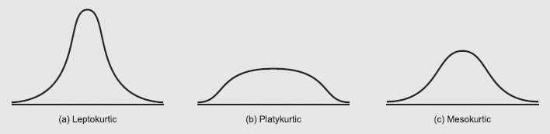

Measures of Kurtosis
The fourth standardized moment μ₄ (or β₂) is a measure of flatness or peakedness of a single humped distribution (also called Kurtosis).
For a normal distribution μ₄ = β₂ = 3 so that γ₂ = 0 and
Hence any distribution having β₂ > 3 will be peaked more sharply than the normal curve known as leptokurtic (narrow). Leptokurtic refers to a frequency curve that is more peaked than the normal curve.
while if β₂ < 3, the distribution is termed as platykurtic (broad).
The value of β₂ is helpful in selecting an appropriate measure of central tendency. For example, if β₂ = 3, mean is preferred;
if β₂ > 3 (leptokurtic distribution), median is preferred;
while for β₂ < 3 (platykurtic distribution), quartile range is suitable.
Platykurtic refers to a frequency curve that is flat-topped than the normal curve.
Remark: W. S. Gosset, explained different shapes of frequency curves as: Platykurtic curves, like the platypas, are squat with short tails; leptokurtic curves are high with long tails like the Kangaroos noted for leaping.
Mesokurtic refers to a frequency curve that is a normal (symmetrical) curve.

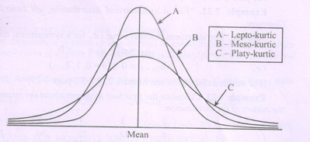
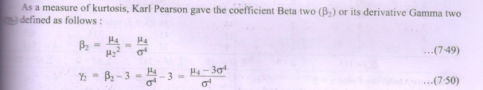

Example: The first four moments of a distribution about the value 5 of the variable are 2, 20, 40, and 50. Show that the mean is 7. Also find the other moments, β₁ and β₂, and comment upon the nature of the distribution.
Solution: From the data of the problem, we have

The moments about the arbitrary point 5 are calculated as follows:

Mean,

Variance,

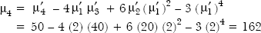

The two constants, β₁ and β₂, calculated from central moments are as follows:

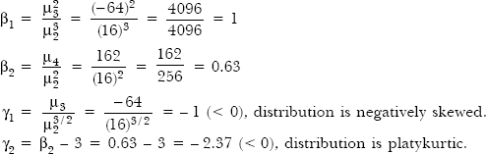

Example : Find the standard deviation and kurtosis of the following set of data pertaining to kilowatt hours (kwh) of electricity consumed by 100 persons in a city.

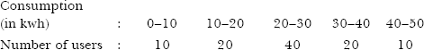

Solution: The calculations for standard deviation and kurtosis are shown in

Table - Calculations of Standard Deviation and Kurtosis
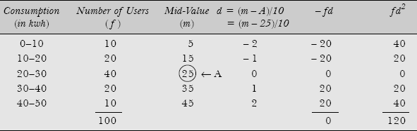

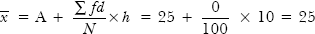

Since = 25 is an integer value, therefore we may calculate moments about the actual mean

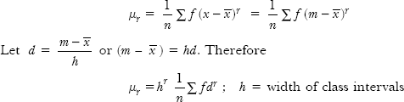

The calculations for moments are shown

Table Calculations for Moments
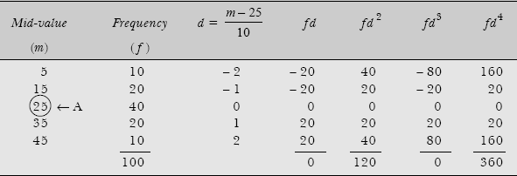

Moments about the origin A = 25 are:

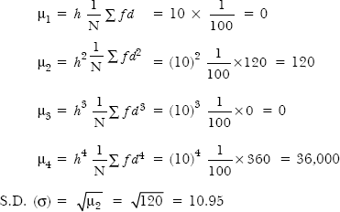

Karl Pearson's measure of kurtosis is given by

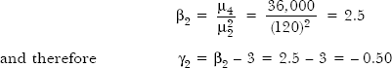

Since β₂ < 3 (or γ₂ < 0), distribution curve is platykurtic.

Example 5.12: Calculate the value of γ₁ and γ₂ from the following data and interpret them.

Comment on the skewness and kurtosis of the distribution. [Kumaon Univ., MBA, 1999]
Solution: Calculations for moments about an arbitrary constant value are shown in Table 5.8.

Table Calculations of Moments
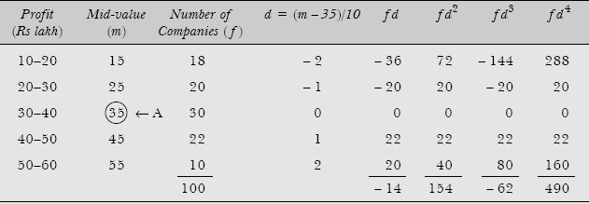

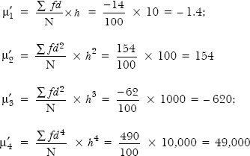

The central moments are as follows:

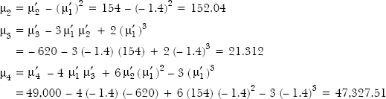

Karl Pearson's relative measure of skewness and kurtosis are as follows:
Measure of skewness,
Measure of kurtosis, 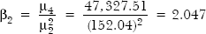

The value of γ₁ = 0.0114 suggests that the distribution is almost symmetrical and γ₂ = – 0.953 (< 0) indicates a platykurtic frequency curve.

